**Method Design：**

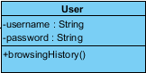

|  |  |  |
| --- | --- | --- |
| **Method** | **parameter** | **Description** |
| +browsingHistory() | - | This method let customer and admin can brow shopping history. |

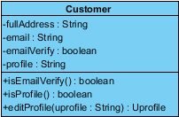

|  |  |  |
| --- | --- | --- |
| **Method** | **parameter** | **Description** |
| +isEmailVerify() | - | This method validate that the username is an email format. |
| +isProfile() | - | This method validate that the user picture is a correct format. |
| +editProfile() | uprofile:String | This method let customer edit personal information after register. |

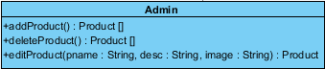

|  |  |  |
| --- | --- | --- |
| **Method** | **parameter** | **Description** |
| +addProduct() | Product[] | This method let admin add product to product list. |
| +deleteProduct() | Product[] | This method let admin delete product from product list. |
| +editProduct() | pname:String, desc:String, image:String | This method let admin edits product where name, description and image. |



|  |  |  |
| --- | --- | --- |
| **Method** | **parameter** | **Description** |
| +validateCustomerName() | name:String | This method validate customer name whether or not is a registered name. |
| +validatePassword() | password:String | This method validate customer password whether or not is right. |

|  |  |  |
| --- | --- | --- |
| **Method** | **parameter** | **Description** |
| +validatePassword() | password : String | This method validate whether or not customer’s password is a right format |
| +checkConfirmPassword() | password : String, repassword : String | This method checks customer confirm password whether or not is the same as an inputted password. |
| +validateName() | name : String | This method validate whether or not a right name format. |
| +checkPicture() | picture:String | This method checks customer picture whether or not is picture format. |
| +checkAddress() | address:String | This method is checks whether or not customer address is valid. |

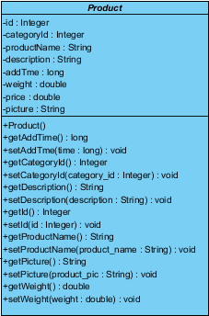

|  |  |  |
| --- | --- | --- |
| **Method** | **parameter** | **Description** |
| +product() | - | This method provides product project. |

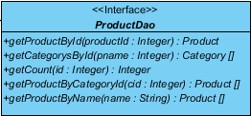

|  |  |  |
| --- | --- | --- |
| **Method** | **parameter** | **Description** |
| +getProductById() | productId: Integer | - |
| +getCategorysById() | Pname: Integer | - |
| +getCount() | id: Integer | - |
| +getProductByCategoryId() | cid:Integer | - |
| +getProductByName() | name: String | - |

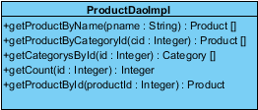

|  |  |  |
| --- | --- | --- |
| **Method** | **parameter** | **Description** |
| +getProductById() | productId: Integer | - |
| +getCategorysById() | Pname: Integer | - |
| +getCount() | id: Integer | - |
| +getProductByCategoryId() | cid:Integer | - |
| +getProductByName() | name: String | - |

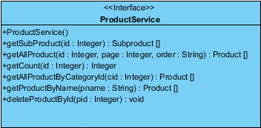

|  |  |  |
| --- | --- | --- |
| **Method** | **parameter** | **Description** |
| +productService() | - | Calling the method of product service where from product DAO implement class. |
| +deleteProductById() | pid: Integer | Calling the method of delete product by ID where from product DAO implement class. |

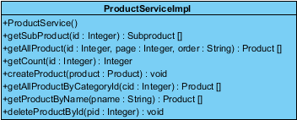

|  |  |  |
| --- | --- | --- |
| **Method** | **parameter** | **Description** |
| +productService() | - | Implement the method of product service where from product service interface. |
| +deleteProductById() | pid: Integer | Implement the method of delete product by ID where from product service interface. |

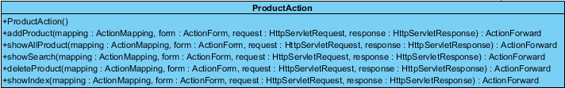

|  |  |  |
| --- | --- | --- |
| **Method** | **parameter** | **Description** |
| +productAction() | - | Calling the method of product action where from product service interface. |
| +addProduct() | mapping : ActionMapping, form : ActionForm,  request : HttpServletRequest, response : HttpServletResponse | Calling the method of add product where from product service interface. |
| +showAllProduct() | mapping : ActionMapping, form : ActionForm,  request : HttpServletRequest, response : HttpServletResponse | Calling the method of show all products where from product service interface. |
| +showSearch() | mapping : ActionMapping, form : ActionForm,  request : HttpServletRequest, response : HttpServletResponse | Calling the method of show search where from product service interface. |
| +deleteProduct() | mapping : ActionMapping, form : ActionForm,  request : HttpServletRequest, response : HttpServletResponse | Calling the method of delete product where from product service interface. |
| +showIndex() | mapping : ActionMapping, form : ActionForm,  request : HttpServletRequest, response : HttpServletResponse | Calling the method of show index page where from product service interface. |

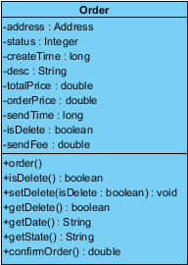

|  |  |  |
| --- | --- | --- |
| **Method** | **parameter** | **Description** |
| +order() | - | This method let customer order items. |
| +isDelete() | - | This method let customer can delete items that he ordered. |
| +confirmOrder() | - | This method let customer confirm order before payment. |

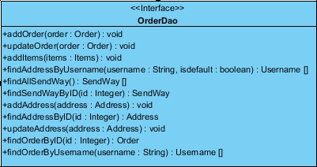

|  |  |  |
| --- | --- | --- |
| **Method** | **parameter** | **Description** |
| +addOrder() | order:Order | Calling the method of add order which from order DAO implement class. |
| +updateOrder() | order : Order | Calling the method of update order which from order DAO implement class. |
| +addItems() | items:Items | Calling the method of add items which from order DAO implement class. |
| +findAddressByUsername() | userid : Integer, isdefault : boolean | Calling the method of find address by username which from order DAO implement class. |
| +findAllSendWayByUsername() | username: String,  isDefault:boolean | Calling the method of find all send way by username which from order DAO implement class. |
| +findAllSendWay() | SendWay[] | Calling the method of find all send way which from order DAO implement class. |
| +addAddress() | address:Address | Calling the method of add address which from order DAO implement class. |
| +findAddressByID() | id:intdger | Calling the method of find address by ID where from order DAO implement class. |
| +updateAddress() | address : .Address | Calling the method of update address where from order DAO implement class. |
| +findOrderById() : | id:integer | Calling the method of find order by Id where from order DAO implement class. |
| +findOrderByUsername() | Username:String | Calling the method of find order by username where from order DAO implement class. |

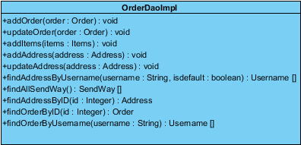

|  |  |  |
| --- | --- | --- |
| **Method** | **parameter** | **Description** |
| +addOrder() | order:Order | Implement the method of add order which from order DAO interface. |
| +updateOrder() | order : Order | Implement the method of update order which from order DAO interface. |
| +addItems() | items:Items | Implement the method of add item which from order DAO interface. |
| +findAddressByUsername() | userid : Integer, isdefault : boolean | Implement the method of find address by username which from order DAO interface. |
| +findAllSendWayByUsername() | username: String,  isDefault:boolean | Implement the method of find all send way by username which from order DAO interface. |
| +findAllSendWay() | SendWay[] | Implement the method of find all wend which from order DAO interface. |
| +addAddress() | address:Address | Implement the method of add address which from order DAO interface. |
| +findAddressByID() | id:intdger | Implement the method of find address by ID which from order DAO interface. |
| +updateAddress() | address : .Address | Implement the method of update address which from order DAO interface. |
| +findOrderById() : | id:integer | Implement the method of find order by id which from order DAO interface. |
| +findOrderByUsername() | Username:String | Implement the method of find order by username where from order DAO interface. |

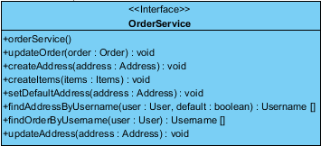

|  |  |  |
| --- | --- | --- |
| **Method** | **parameter** | **Description** |
| +orderService() | - | Calling the method of order service where from order DAO implement class. |
| +updateOrder() | order:Order | Calling the method of update order which from order DAO implement class. |
| +createAddress() | address : Address | Calling the method of create address which from order DAO implement class. |
| +createItems() | items : Items | Calling the method of create items which from order DAO implement class. |
| +findAddressByUsername() | user : User, default : boolean | Calling the method of find address by username which from order DAO implement class. |
| +findOrderByUsername() | user :User | Calling the method of find order by username which from order DAO implement class. |
| +updateaAddress() | address:Address | Calling the method of update address which from order DAO implement class. |

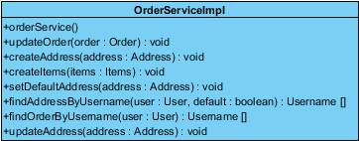

|  |  |  |
| --- | --- | --- |
| **Method** | **parameter** | **description** |
| +orderService() | - | Implement the method of order service where from order service interface. |
| +updateOrder() | order:Order | Implement the method of update order which from order service interface. |
| +createAddress() | address : Address | Implement the method of create address which from order service interface. |
| +createItems() | items : Items | Implement the method of create items which from order service interface. |
| +findAddressByUsername() | user : User, default : boolean | Implement the method of find address by username which from order service interface. |
| +findOrderByUsername() | user :User | Implement the method of find order by username which from order service interface. |
| +updateaAddress() | address:Address | Implement the method of update address which from order service interface. |

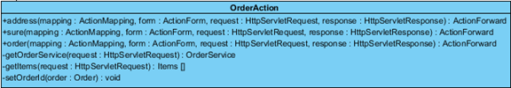

|  |  |  |
| --- | --- | --- |
| **Method** | **parameter** | **Description** |
| +address() | mapping : ActionMapping, form : ActionForm,  request : HttpServletRequest, response : HttpServletResponse | Calling the method of address where from order service interface. |
| +sure() | mapping : ActionMapping, form : ActionForm,  request : HttpServletRequest, response : HttpServletResponse | Calling the method of sure which from order service interface. |
| +order() | mapping : ActionMapping, form : ActionForm,  request : HttpServletRequest, response : HttpServletResponse | Callng the method of order which from order service interface. |

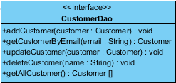

|  |  |  |
| --- | --- | --- |
| **Method** | **parameter** | **Description** |
| +addCustomer() | customer : Customer | Calling the method of add customer which from customer DAO implement class. |
| +updateCustomer() | customer :Customer | Calling the method of update customer where from customer DAO implement class. |
| +deleteCustomer() | name : String | Calling the method of delete customer where from customer DAO implement class. |

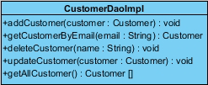

|  |  |  |
| --- | --- | --- |
| **Method** | **parameter** | **Description** |
| +addCustomer() | customer : Customer | Implement the method of add customer which from customer DAO interface. |
| +updateCustomer() | customer :Customer | Implement the method of update customer where from customer DAO interface. |
| +deleteCustomer() | name : String | Implement the method of delete customer where from customer DAO interface. |

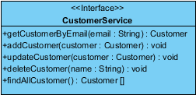

|  |  |  |
| --- | --- | --- |
| **Method** | **parameter** | **Description** |
| +addCustomer() | customer : Customer | Calling the method of add customer which from customer DAO implement class. |
| +updateCustomer() | customer :Customer | Calling the method of update customer which from customer DAO implement class. |
| +deleteCustomer() | name : String | Calling the method of delete customer where from customer DAO implement class. |
| +findAllCustomer() | - | Calling the method of find all customers which from customer DAO implement class. |

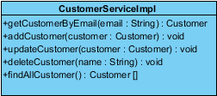

|  |  |  |
| --- | --- | --- |
| **Method** | **parameter** | **Description** |
| +addCustomer() | customer : Customer | Implement the method of add customer which from customer service interface. |
| +updateCustomer() | customer :Customer | Implement the method of update customer where from customer service interface. |
| +deleteCustomer() | name : String | Implement the method of delete customer where from customer service interface. |
| +findAllCustomer() | - | Implement the method of find customer where from customer service interface. |

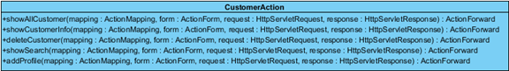

|  |  |  |
| --- | --- | --- |
| **Method** | **parameter** | **Description** |
| +showAllCustomer() | mapping : ActionMapping, form : ActionForm,  request : HttpServletRequest, response : HttpServletResponse | Calling the method of show all customers which from customer service interface. |
| +showCustomerInfo() | mapping : ActionMapping, form : ActionForm,  request : HttpServletRequest, response : HttpServletResponse | Calling the method of show customer information where from customer service interface. |

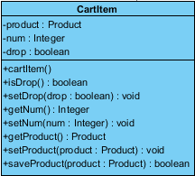

|  |  |  |
| --- | --- | --- |
| **Method** | **parameter** | **Description** |
| +cartItem() | - | This method provides cart item object. |
| +isDrop() | - | This method check cart item whether or not is drop. |
| +saveProduct() | product:Product |  |

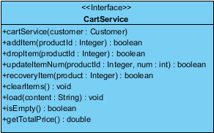

|  |  |  |
| --- | --- | --- |
| **Method** | **parameter** | **Description** |
| +cartService() | customer : Customer | Calling the method of cart service where from cart DAO implement class. |
| +addItem() | productId : Integer | Calling the method of add item which from cart DAO implement class. |
| +dropItem() | productId : Integer | Calling the method of drop item which from cart DAO implement class. |
| +updateItemNum() | productId : Integer, num : int | Calling the method of update item number where from cart DAO implement class. |
| +recoveryItem() | product : Integer | Calling the method of recovery item which from cart DAO implement class. |
| +clearItems() | - | Calling the method of clear item which from cart DAO implement class. |
| +load() | content : String | Calling the method of load where from cart DAO implement class. |
| +isEmpty() | - | Calling the method of is empty which from cart DAO implement class. |

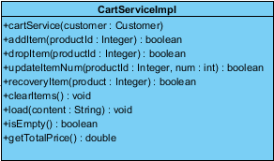

|  |  |  |
| --- | --- | --- |
| **Method** | **parameter** | **Description** |
| +cartService() | customer : Customer | Implement the method of cart service where from cart service interface. |
| +addItem() | productId : Integer | Implement the method of add item which from cart service interface. |
| +dropItem() | productId : Integer | Implement the method of drop item which from cart service interface. |
| +updateItemNum() | productId : Integer, num : int | Implement the method of update item number which from cart service interface. |
| +recoveryItem() | product : Integer | Implement the method of recovery item which from cart service interface. |
| +clearItems() | - | Implement the method of clear items which from cart service interface. |
| +load() | content : String | Implement the method of load where from cart service interface. |
| +isEmpty() | - | Implement the method of is empty which from cart service interface. |

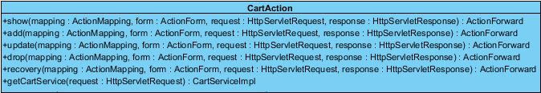

|  |  |  |
| --- | --- | --- |
| **Method** | **parameter** | **Description** |
| +show() | mapping : ActionMapping, form : ActionForm,  request : HttpServletRequest, response :  HttpServletResponse | Calling the method of show where from cart service interface. |
| +add() | mapping : ActionMapping, form : ActionForm,  request : HttpServletRequest, response : HttpServletResponse | Calling the method of add which from cart service interface. |
| +update() | mapping : ActionMapping, form : ActionForm,  request : HttpServletRequest, response : HttpServletResponse | Calling the method of update which from cart service interface. |
| +drop() | mapping : ActionMapping, form : ActionForm,  request : HttpServletRequest, response : HttpServletResponse | Calling the method of drop wherefrom cart service interface. |
| +recovery() | mapping : ActionMapping, form : ActionForm,  request : HttpServletRequest, response : HttpServletResponse | Calling the method of recovery where from cart service interface. |

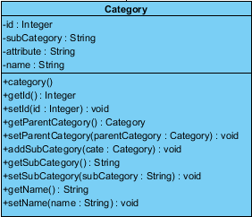

|  |  |  |
| --- | --- | --- |
| **Method** | **parameter** | **Description** |
| +category() | name : String | This method provides category object. |

C:\Users\ADMINI~1\AppData\Local\Temp\ksohtml\wps_clip_image-8448.png

|  |  |  |
| --- | --- | --- |
| **Method** | **parameter** | **Description** |
| +findCategoryByName() | name : String | Calling the method of find category by name which from category DAO implement class. |

C:\Users\ADMINI~1\AppData\Local\Temp\ksohtml\wps_clip_image-20890.png

|  |  |  |
| --- | --- | --- |
| **Method** | **parameter** | **Description** |
| +findCategoryByName() | name : String | Implement the method of find category by name where from category DAO interface. |



|  |  |  |
| --- | --- | --- |
| **Method** | **parameter** | **Description** |
| +getCategoryByName() | name: String | - |



|  |  |  |
| --- | --- | --- |
| **Method** | **parameter** | **Description** |
| +getCategoryByName() | name: String | - |

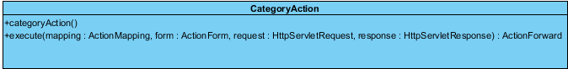

|  |  |  |
| --- | --- | --- |
| **Method** | **parameter** | **Description** |
| +categoryAction() | - | Calling the method of category action where from cart service interface. |
| +execute() | mapping :ActionMapping, form :ActionForm, request :HttpServletRequest, response :http.HttpServletResponse | Calling the method of execute where from cart service interface. |